NOTICE FOR EARLY VOTING ON SATURDAY AND/OR SUNDAY
AVISO PARA LA VOTACIÓN ANTICIPADA EL SÁBADO Y/O DOMINGO

For the Joint Primary Election to be held on March 3, 2026, additional early voting will be held as follows:

Para las elecciones primarias conjuntas que se celebrarán el 3 de marzo de 2026, se realizarán votaciones anticipadas adicionales de la siguiente manera:

Saturday, February, 21, 2026, 7am-7pm
Sunday, February 22, 2026, 12pm-6pm (Courthouse Only)

Issued this 16th day of January, 2026.
Emitido este 16 de enero de 2026.

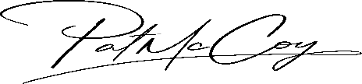
Pat McCoy
Bowie County Elections
Election Administrator

